Rugged Tablet with GNSS RTK-High-Precision GNSS Positioning

The Y100-RTK (5G) is an 5G GNSS RTK Rugged Tablets from lqvis. 10.1-inch high-definition large screen, equipped with a high-performance 8-core 2.7GHz processor, Android 13 operating system, and 5G communication. Standard configuration includes 4G+64G memory, optional options: 6G+128G, 8G+128G, 8G+256G. Built in 10000mAh high-capacity battery with IP67 protection level.
Integrated high-sensitivity GNSS module, built-in RTK algorithm, paired with four arm spiral antenna, supporting centimeter level accuracy. Support BDS, GPS, GALILEQ, GLONASS, QZSS full system GNSS.
Strong industry adaptability, widely used in application fields such as land, electricity, forestry, environmental protection, highways, railways, ship monitoring, oil and gas pipelines, mining exploration, etc.
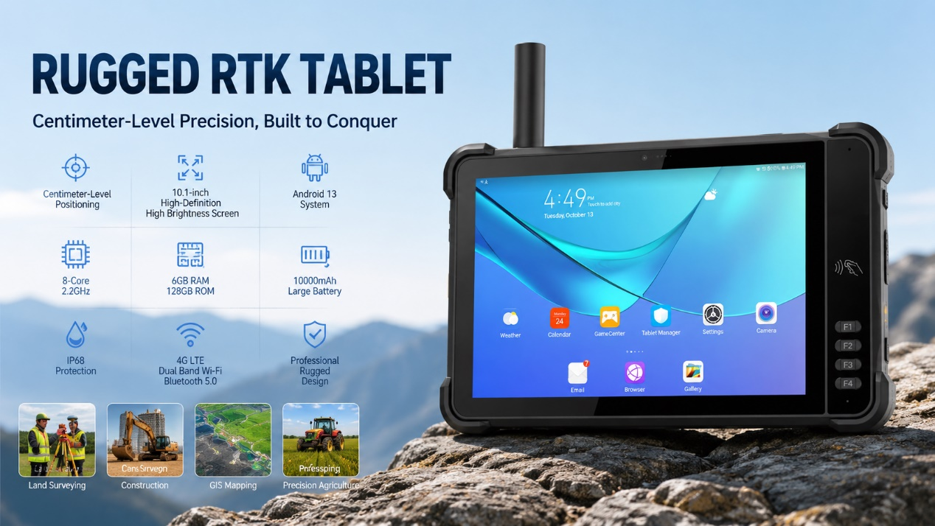

Basic Information
processor | UNISOC 7885（ 1*A76@2.7GHz+3*A76@2.3GHz+4*A55@2.1GHz）
operating system | Android 13
RAM+ROM | 4GB +64GB ； Optional: 6G+128G; 8G+128G； 8G+256G
Expand memory | Micro SD card, supports up to 512GB
display | 10.1 inches, resolution: 800 * 1280 550 nits.  Optional: 10.1-inch/1920 * 1200/IPS 600nits/Supports glove mode/wet hand mode
Touch Screen | Capacitive screen: supports multi touch, glove touch
Rear camera | Rear 1600W pixels support autofocus and flash
Front Camera | Front 500W pixel (optional)
audio | Main MIC*1, Noise Reduction and Echo Cancellation*1
audio | Speaker (4W) * 1
prompt | 2 RGB lights
prompt | Vibrating motors
keystroke | Left: Volume +-, Scan key  Right side: Power on button  Front: 4 custom function keys
External interfaces | Left: TYPC-A  Right side: SIM card holder + TF card holder, TYPC-C  Top: PSAM card holder (optional), RTK antenna interface (optional)  Underside: 4PIN charging interface  Back: Expansion interface (customized)
Booths | Nano SIM card * 2&Nano SIM card x 1+T_FLASH * 1
sensor | Light proximity sensor, gravity sensor  optional :Compass, air pressure sensor
battery | 10000 mAh polymer lithium battery,  Standby time> 350 hours  Working time> 12 hours (depending on the usage environment)  The charging time is 3-4 hours, using the standard power adapter and data cable  10000 mAh + larger battery (customized).
Charging method | Type-C 30W PD fast charging
Communication Transmission
WLAN function | 2.4/5G, 802.11a/b/g/n/ac
Bluetooth | BT5.0
GNSS | GPS/GLONASS/Galileo/Beidou, L1
Wireless WAN (Network Frequency) | 5G NR: n1/n3/n5/n8/n28/n41/n78/n79  LTE-FDD: B1/B3/B5/B8  LTE-TDD: B34/B38/B39/B40/B41  WCDMA: B1/B5/B8  GSM: B3/B8
RTK
parameter | performance indicators
GNSS tracking channel | 1408
GNSS receiving frequency point | GPS/QZSS: L1C/A, L2C, L5
GNSS receiving frequency point | BDS: B1, B2, B2a, B31.
GNSS receiving frequency point | Galileo: E1. E5a
GNSS receiving frequency point | GLONASS: L1,L2.
Data update rate | PVT maximum value 10Hz
Data update rate | RTK maximum value 5Hz
positioning accuracy | GNSS 2.5m CEP
positioning accuracy | D-GNSS <1.0m CEP
positioning accuracy | RTK 1.5cm+ 1ppm(H)
Speed and time accuracy | GNSS 0.1m/s CEP
Speed and time accuracy | 1PPS 20ns
Time of first positioning (TTFF) | Hot start for 2 seconds
Time of first positioning (TTFF) | Cold start for 24 seconds
Time of first positioning (TTFF) | RTK convergence time<10s
sensitivity | Cold start -148dBm
sensitivity | Hot start -158dBm
sensitivity | Re capture -160dBm
sensitivity | Tracking&Navigation -1 62 dBm
Application limits | Speed 515 meters per second
Application limits | Height 18000 meters
Optional functions
NFC | Operating frequency: 13.56MHz  agreement ：ISO14443A/B, ISO15693, NFC-IP1, NFC-IP2  Tag standard: M1 card(S50, S70), CPU card, NFC tag, etc  Reading and writing distance: 1-3cm
Environmental parameters
Operating temperature | -20℃~55℃  *For safety reasons, do not charge in a low temperature environment
Storage temperature | -40°C~70°C (without battery)
humidity | 0~95% (no condensation)
Drop Specs | The 1.2-meter concrete floor fell many times
Ingress protection | IP67
Electrostatic discharge | ±15KV (air discharge), ±8KV (contact discharge)
Development support
Development language | Java
Develop APIs | Android standard interface
Structural parameters
Dimensions (mm). | 290.6*182.5*18.5mm
Weight as standard | 980g
Equipment accessories
Standard accessories | Adapters, data cables, protective films

Provide ODM and OEM customized services
• We work closely with our partners and can provide various one-stop customized solutions.
• Appearance customization: supports customization of product nameplates, product packaging, and promotional materials.
• Hardware customization: Supports customization of functional modules and optional hardware functions.
• Software customization: supports customization of boot interface, boot program, kernel clipping, and API interface.
• Technical support: Provide SDK development kits and application software development technical services.

